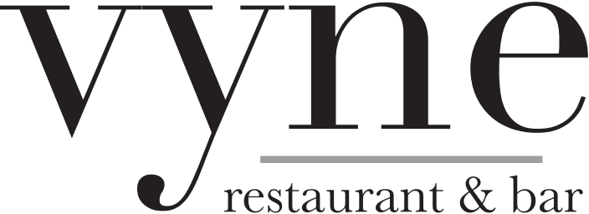

The Whittemore at Vyne
Wedding Packages

Stationary Hors d’oeuvres

Crudites Display
Artful arrangement of fresh vegetables served with hummus, ranch, and spinach dip

Antipasto Display
Assorted cured meats, fresh mozzarella, parmesan, provolone, Prosciutto, assorted olives, artichoke hearts, & roasted peppers served with sliced baguette and crostini

Salad Course

Vyne Salad
Mixed greens, shredded carrots, tomatoes, red cabbage, cucumbers, and red onions
with white balsamic dressing

Pasta

Penne pasta tossed with Marinara or Vodka sauce

Entrees
All entrees served with a choice of whipped garlic mashed potatoes, roasted potatoes, baked potato,
or rice pilaf
All entrees served with a choice of seasonal mixed vegetables or asparagus

Pesto Encrusted Black Pearl Salmon

Stuffed Chicken Breast
with Sundried tomatoes, spinach, artichoke hearts, and parmesan cheese

Beef Bourguignon
beef tenderloin tips in a burgundy wine

Coffee and Hot Tea included

$115 PER PERSON
Beverages other than coffee & hot tea are an additional fee
CT Sales Tax (7.35%) and Service Fee (22%) will be added
Bar packages are an additional fee

The Whittemore at Vyne Open Bar Suggestions

Standard Bar Package
$12 per person per hour for 3 hours, $8 each additional hour

Sweet and Dry Vermouth 2 Draft Beers - 1 IPA 1 Lager
Triple Sec 4 Bottled Beers – Budweiser, Bud Light, Heineken, Heineken 0
Kahlua Select 1 Red Wine
Canadian Club Pinot Noir, Cabernet Sauvignon, Chianti Classico
Malibu Rum Select 1 White Wine
Tito’s Vodka Pinot Grigio, Chardonnay, Sauvignon Blanc
Lunazul Tequila
Beefeater Gin Cardinale French Sparkling Wine
Bacardi Rum
Captain Morgan Spiced Rum
Dewars
Jim Beam

Premium Bar Package
$16 per person per hour for 3 hours, $12 each additional hour

Maker’s Mark 2 Draft Beers – 1 IPA 1 Lager
Jack Daniels 4 Bottled Beers – Budweiser, Heineken, Bud Light, Heineken 0
Grey Goose Vodka Select 2 Red Wines
Hendricks Gin Pinot Noir, Cabernet Sauvignon, Syrah, Chianti Classico
Goslings Rum Select 2 White Wines
Captain Morgan Private Stock Pinot Grigio, Chardonnay, Sauvignon Blanc
Bacardi Rum Silver
Patron Silver
Hennessy VSOP
Johnny Walker Black *Special requests available and subject to additional charges
Kahlua ** All packages include bar set up of mixers, juices, cordials,
Malibu fruits, vermouths, and soft drinks
Crown Royal ***There are no “shots” permitted
Jameson
Tito’s Vodka

*Service Fee (22%) and CT Sales Tax (7.35%) and will be added to all wedding packages

